**NAAN MUDHAVAN**

**PROJECT DOCUMENT**

**COURSE TITLE** : DIGITAL MARKETING

**COLLEGE CODE** : 1105

**COLLEGE NAME** : GOJAN SCHOOL OF BUSINESS AND TECHNOLOGY

**PROJECT TITLE** : CREATE BRAND NAME, BRAND MAIL AND BRAND LOGO IN CANVA

**PROJECT TEAM** ID: NM2023TMID05721

**TEAM LEADER**

**NM ID** : B7209538F6EF939896445762AE7F52A3

**NAME** : PAVITHRA L

**TEAM MEMBER 1**

**NM ID** : CD44BBA83E9CC7F94354FFCB19DBA5F9

**NAME** : NIVETHA.T

**TEAM MEMBER 2**

**NM ID** : C0647F5B594260BB5F94EACB0FF35DF1

**NAME** : SATHYA.S

**TEAM MEMBER 3**

**NM ID** : FDF194F4A53B3E290434DADBB14DAB8E

**NAME** : SHINE SOLOMON.M

**TEAM MEMBER 4**

**NM ID** : 9D715754644F780B3774B48FA69AB89D

**NAME** : TAMIZH SELVI.K

**BRAND NAME** : SHADES OF CAKES

**CATEGORY :** BAKING

**BRAND MAIL-ID** : [shadesofcakes28@gmail.com](mailto:shadesofcakes28@gmail.com)

**PASSWORD** : pavinive28

**TARGET AUDIENCE**  : Children, Special Occasions, Vegetarian Audiences,customized cakes.

**BRAND LOGO**



**STEPS:** 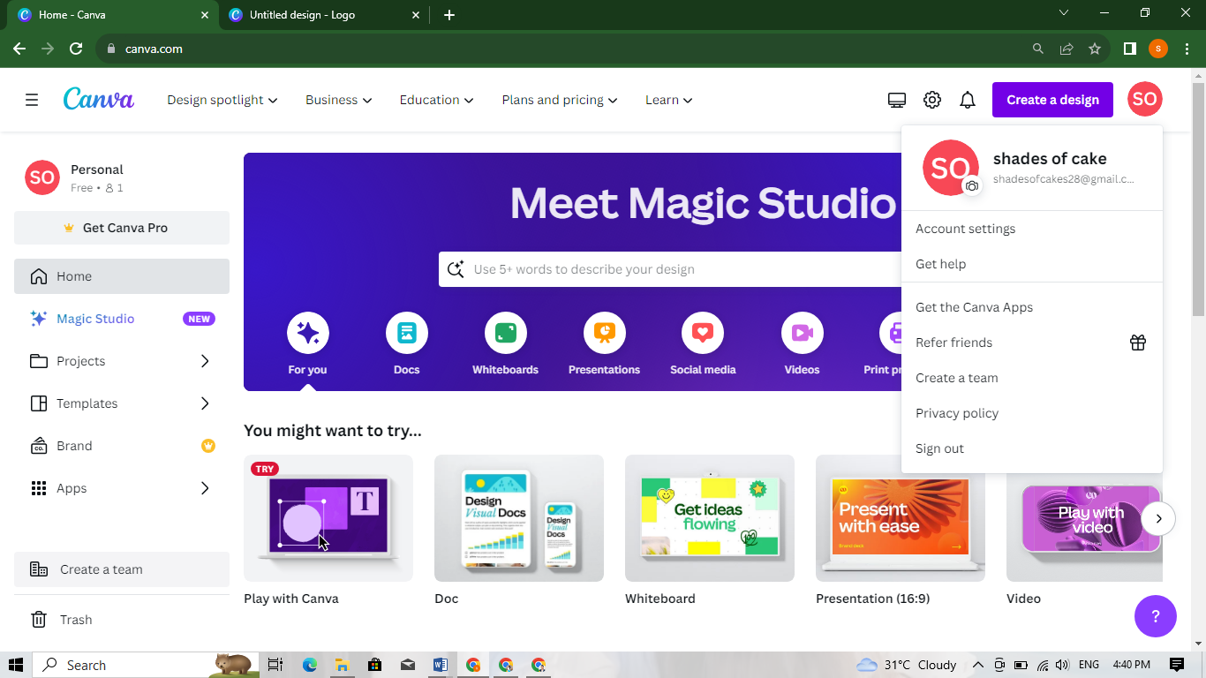

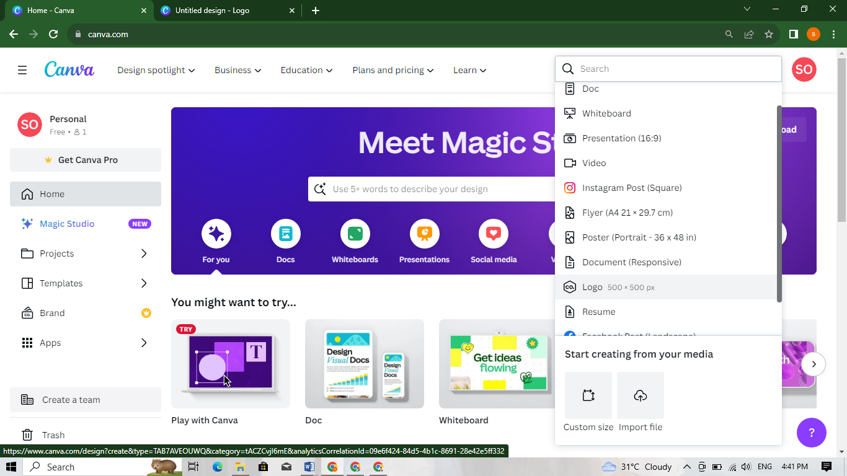

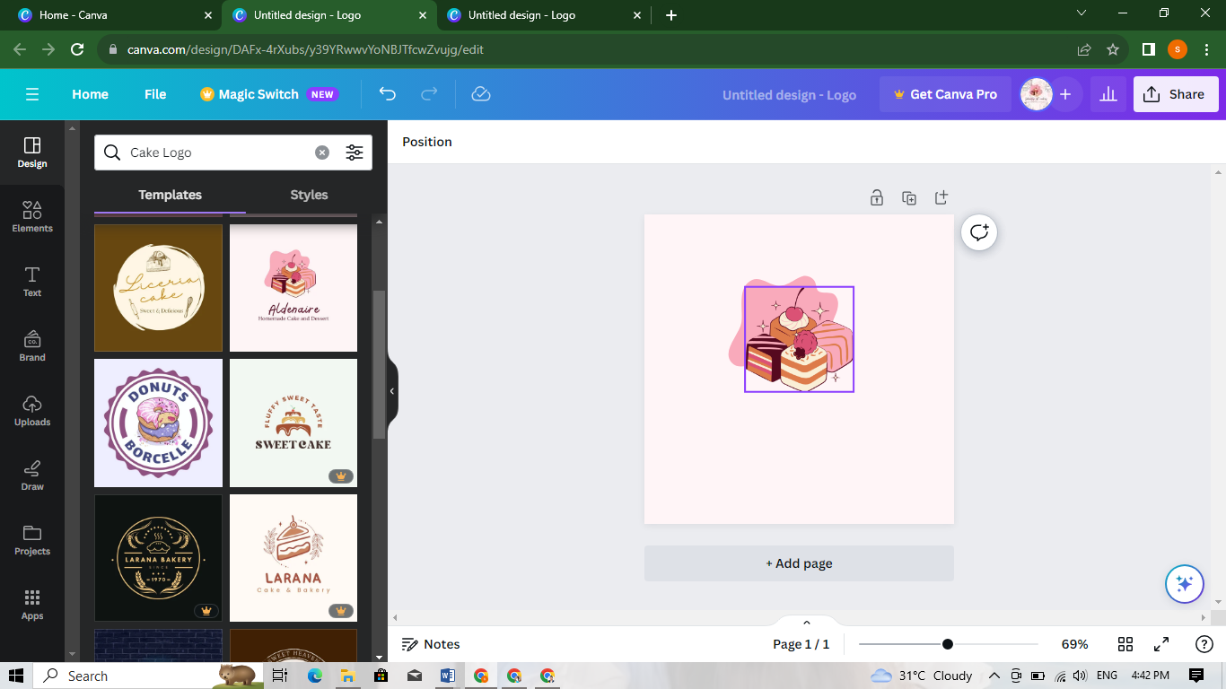

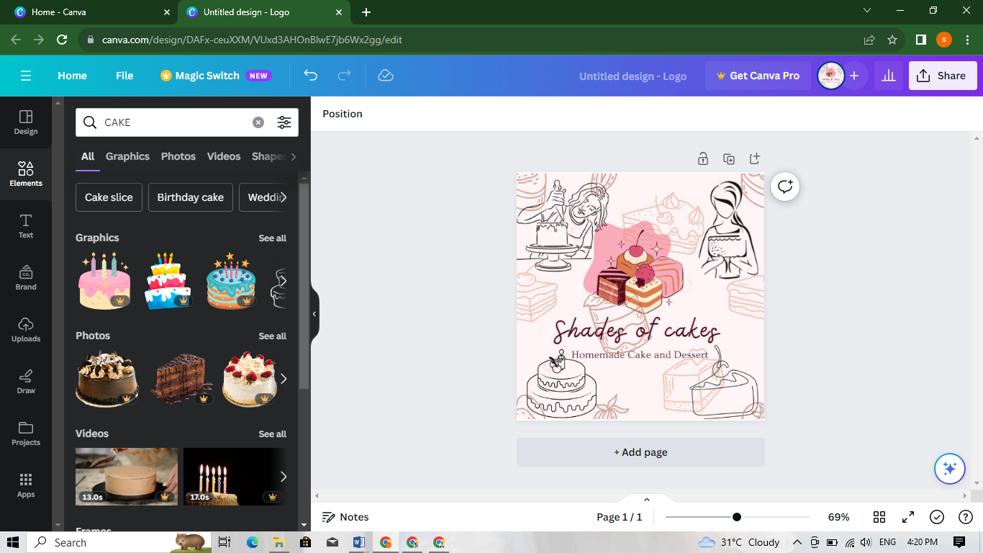

**EMPATHY MAP:**

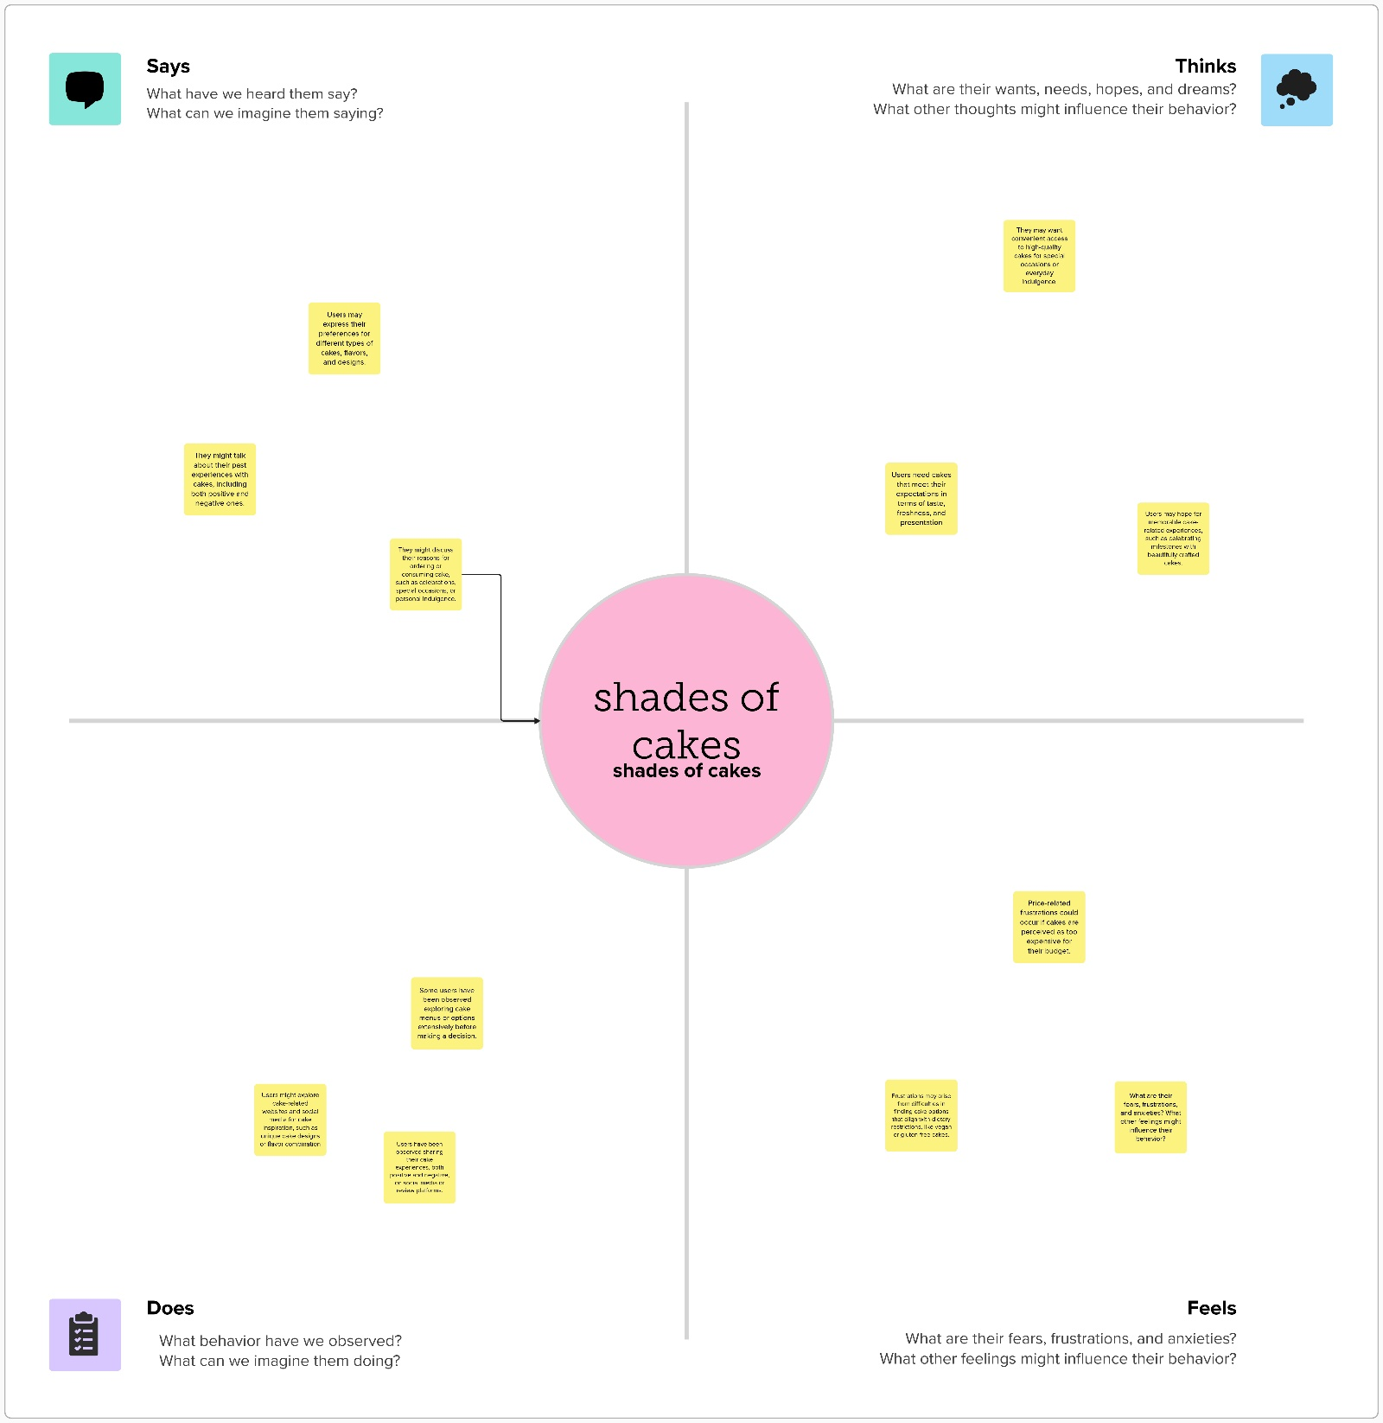

BRAINSTORMING:

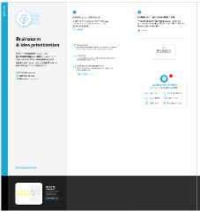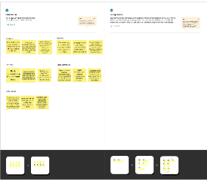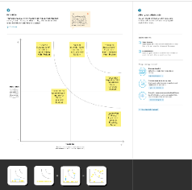

**DRIVE LINK**

<https://drive.google.com/drive/folders/1diBPJSLn9tFiqvBN_ryfzyrKKVWEgTid>